Easter Sunday 12 April 2020

Acts 10:34, 37-43; Psalm 118; Colossians 3:1-4; John 20:1-8

Ignatius Loyola, in his Spiritual Exercises invites us to imagine or think of the Trinity looking on the whole world in all its diversity of cultures … seeing births and deaths, wars and peace-making, tears and laughter, health and sickness. In a heart-felt response to this world view, “God sent his beloved Son.”
This is Jesus whose “state was divine but who did not cling to his equality with God. This is Jesus who became one like us, and humbler yet…” (Phil 2:6-7)
This is Jesus who absorbed the groaning of the earth and all the human suffering that was, is and is to come.

Today, the Risen Jesus comes into our world made desolate by Covid 19. Here, the past weeks have seen people torn between hope and reality. In this season of isolation within our bubbles or self-isolation, a longing for the re-kindling of friendships and deeper relationships stirs, and a yearning for a more just and compassionate way of living that respects the earth and all people.
The Risen Jesus stands among us and assures us of the transformation of humanity and the planet Earth, through the energy of love.

In the Spiritual Exercises of Ignatius Loyola (# 219) Ignatius invites us to pray with a scene where the Risen Jesus meets his mother. Imagine the tender joy of their shared presence and the realisation that the empty tomb was not the end but a fresh beginning in faith.

As you pray, imagine this Risen Jesus entering into your life today, as he meets Mary Magdalen in today’s Gospel.
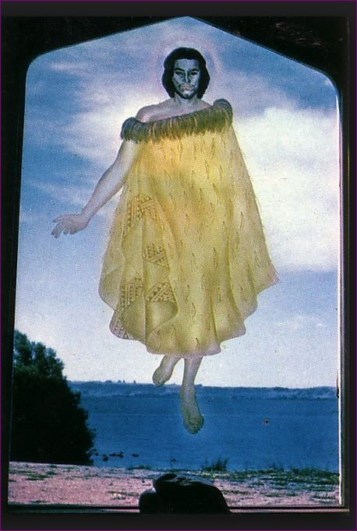
Mary questioned “the gardener”. “Tell me where you have put Him.” She was so caught in her own world of loss and grief that she didn’t notice who was right before her eyes. Take time to become aware of how you are and who or what is around you.

Open your hands in his company.
Ask for what you need at this time in your life. Ask for what your family and our world needs.

Let Him be with you as you are today.
Perhaps his presence comes as light, or warmth, new hope, courage, peace or joy.
Welcome this renewed life of intimacy and companionship.

Breathe out isolation. Breathe in companionship.
Breathe out anxiety. Breathe in peace.
Breathe out desolation. Breathe in joy.

Let the words of the song Deep Within Us by John Sheehan become part of your prayer:
Deep within us
shared among us
may we ever keep
the mind and heart of Jesus Christ.

End by noticing your breathing. Give thanks for the gift of this time of prayer.

-by Anne Powell, Cenacle Sisters
Art- The Maori Christ, St Faith’s Anglican Church Ohinemutu.

