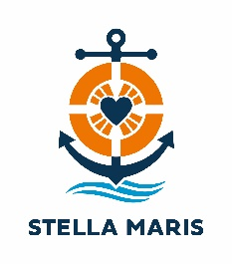
Sea Sunday – 10 July 2022
GENERAL PRAYERS OF INTERCESSION

Priest: As our world continues to suffer the effects of the pandemic, together with the reality of a war in many countries around the world, let us turn to God in prayer.

1. That Pope Francis may be strengthened and protected as he brings people together to forge peace and safety in the world: on land, sea, and sky.
We pray to the Lord. R: Lord, hear our prayer.
2. That all those who minister to seafarers may find hope, peace, and safety in our vulnerable world.
We pray to the Lord. R: Lord, hear our prayer.
3. That the Lord will protect seafarers as they provide our greater human family with food and other primary needs.
We pray to the Lord. R: Lord, hear our prayer.
4. That as the Samaritan traveller was moved with compassion at the sight of the victim, may we support those who help seafarers
We pray to the Lord. R: Lord, hear our prayer.

Priest: Heavenly Father, be with those who are sidelined by society and whose work is not recognised or valued. Sustain them with your grace and enable them to work confidently in your love. Through Christ our Lord. Amen.

