More poems for Week 3 COVID -19

by Anne Powell

Soul space

Your soul is a space
for great flocks of kotuku
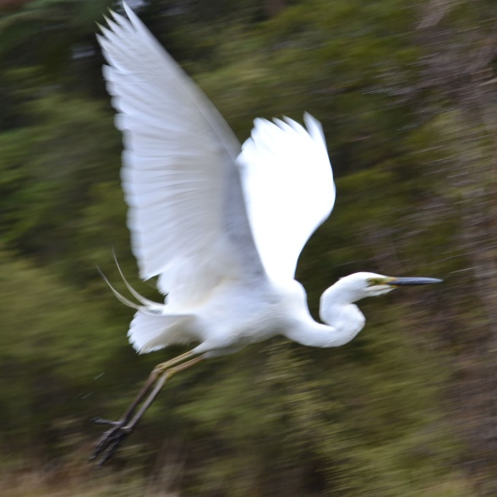
to rise up

or a forest
of quiet rimu
attentive to wind

or water
transparent, quick
in a Tongariro stream.

birds
trees
water

Plant the wisdom tree close to water.
White birds will dance
wing to bright wing
transforming your ruin into joy.

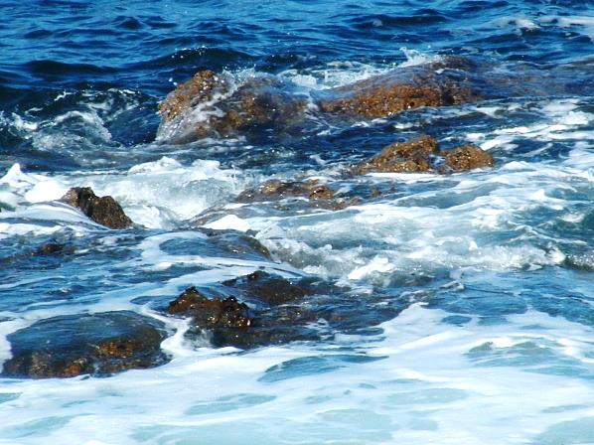
The small boat

There is a small boat
out on the sea
that separates and unites us.

The sea has its own song
called by rhythm of moon
above our earth.

There is a small boat
far from land.
Its sails are open to the unseen wind of the Spirit.
We surrender to the wind.

There is a small boat
out on the sea
beyond maps
and there is bravery.

Crown of stars

The winter Te Arikinui Te Atarangikaahu died
Girlie couldn’t do the tangi.
Terrible asthma.
She rings Tumu.
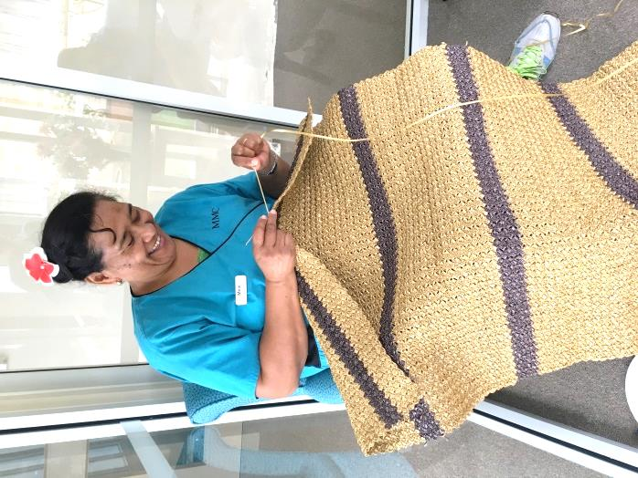
“Are you going to Ngaruawahia?”

“Ae. Ae.”

“If you are there, then I am there too.”

Girlie puts down the phone
in the certainty of communion
and takes up the small tasks of everyday life.

She picks lemons
listens to homework
makes tea for Jack
and stands on her back steps seeking
a new crown of stars
on the dark head of sky.

Anawim
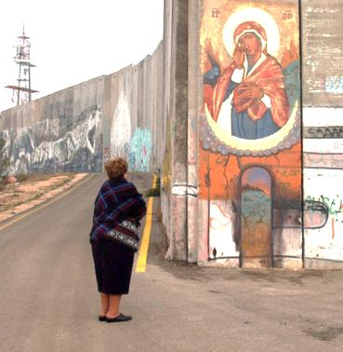
Old woman of Palestine
tends her onions and mint
the slow bend of heard
reverences earth she doesn’t own
hears the moan of wind
in the olive grove.

Old woman of Palestine bends
to be invisible
to the horizon’s glare
bends to bury her voice
beneath the olive tree
believes in new shoots.

Dream rising

Souks awaken.
And oh!
their sounds grow round and round
in thin alleys
where smells of tamarind and cinnamon and almonds
seep into my clothes.
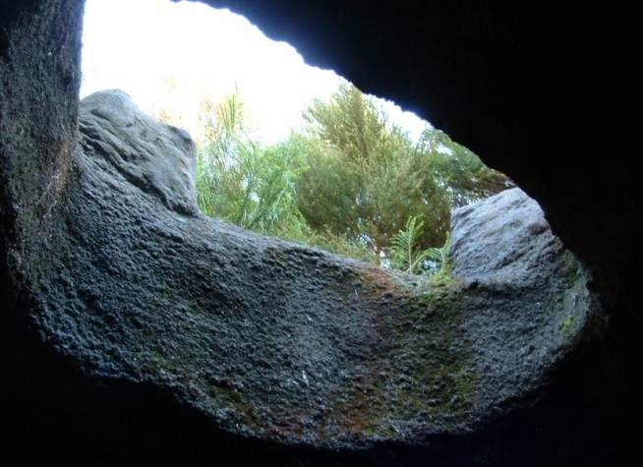
Till in my dreams it seems
I am woman of Jerusalem.

By Damascus Gate
an old Arab
hawks eggs and breads
from a box on a bicycle
his face ravined
with loss of land.
Tilll in my dreams it seems
I am a place to stand.

The tomb guard
a man upright and grand
as a piano.
His ivory hands
hurry people along.
Till in my dreams it seems
I am a song
bright in the breast of a lark
rising.

Grace
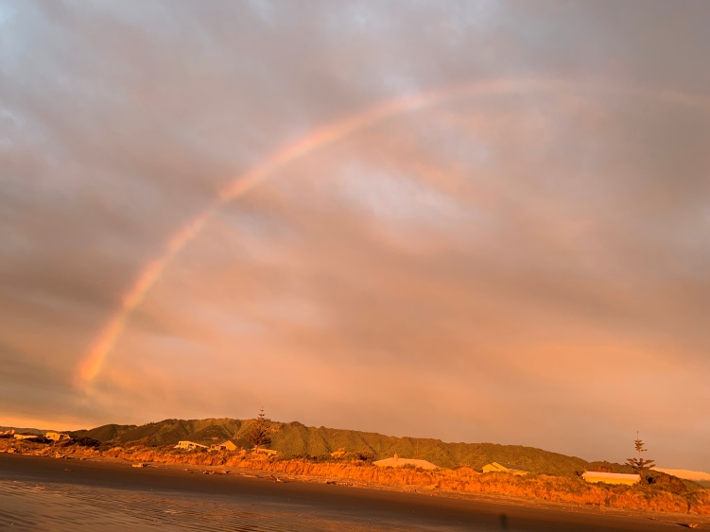
A warm wind is worrying the curtains
rattling flax
blowing grace
all over the place.

Grace
falling from sky
healing earth
lapping on shore
glowing in eyes
dawning Christ.

