Mews Mass – Lord have Mercy

Douglas Mews
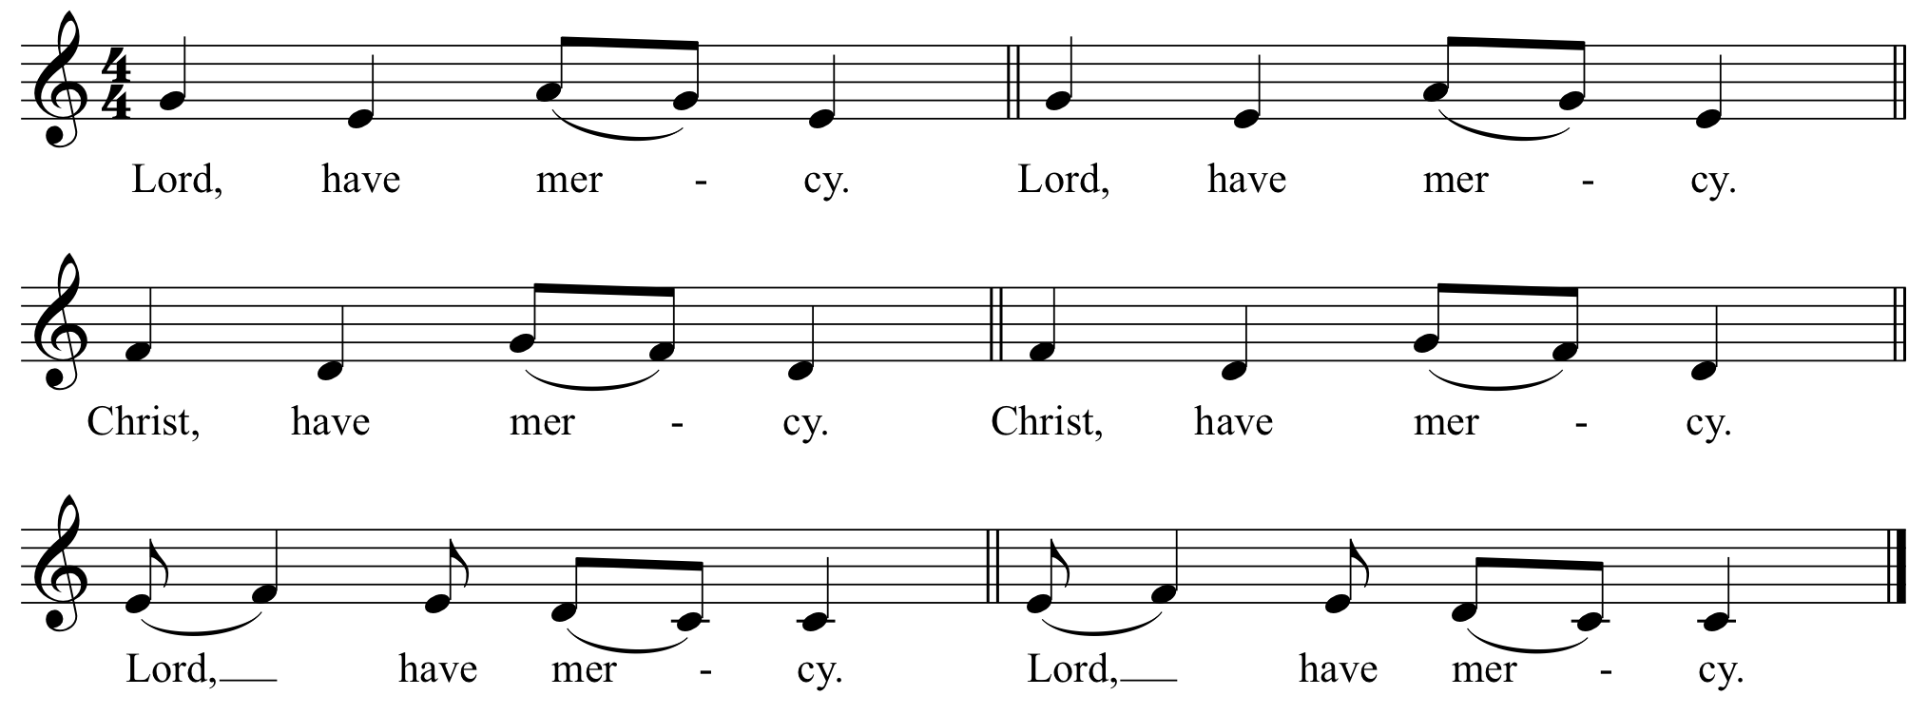

Mews Mass – Lord have Mercy

Douglas Mews
P. Lord, have mercy.
A. Lord, have mercy.
P. Christ, have mercy.
A. Christ, have mercy.
P. Lord, have mercy.
A. Lord, have mercy.

Mews Mass – Gloria

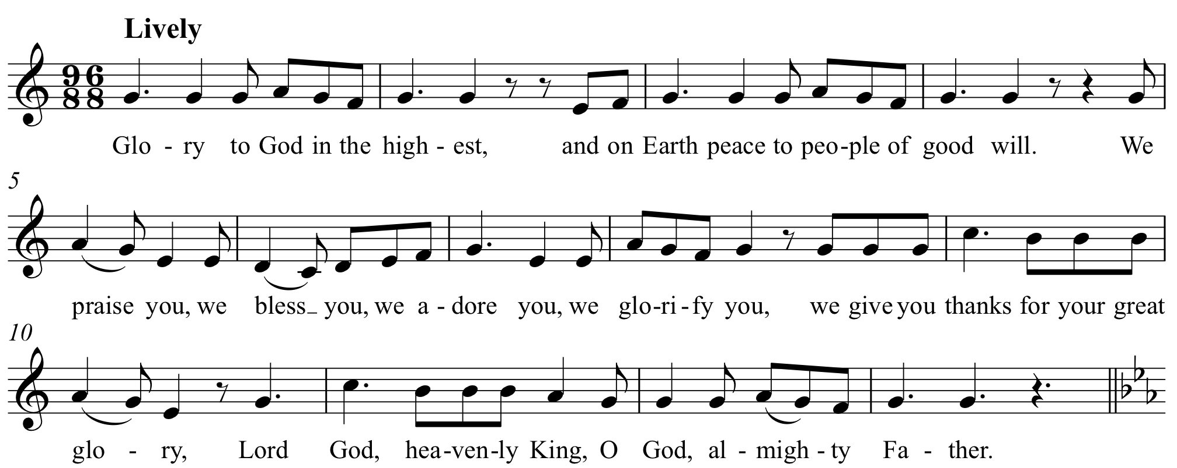
Douglas Mews

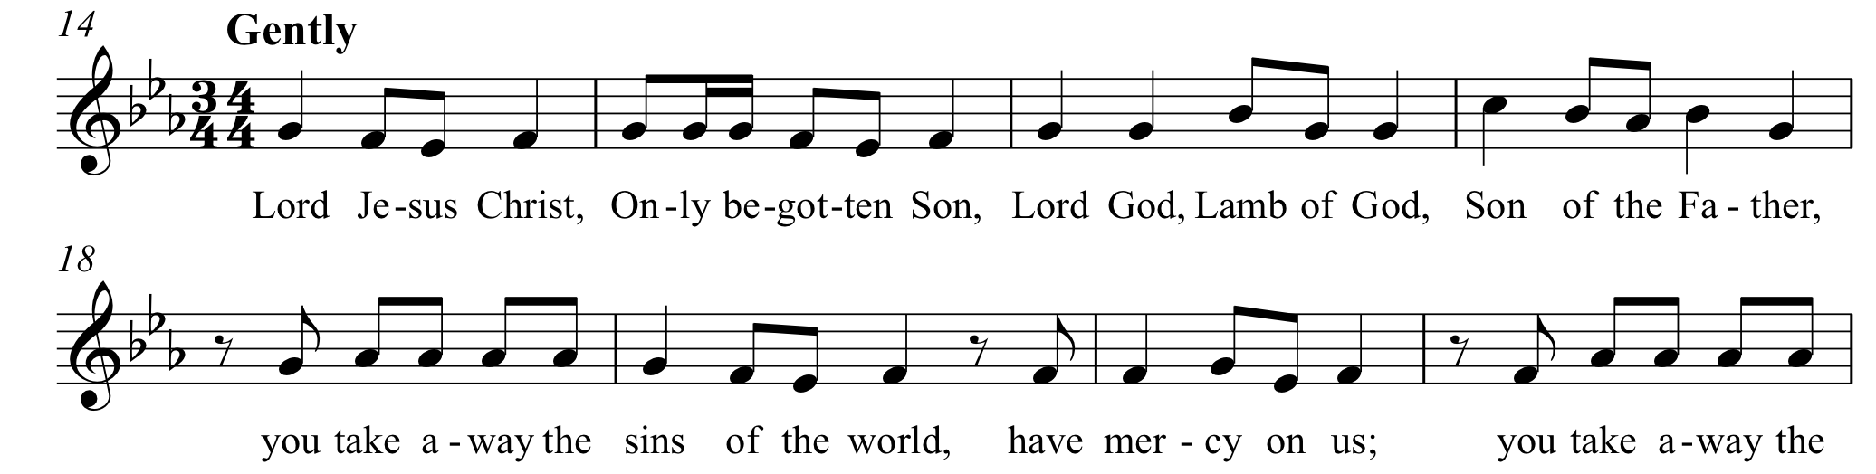
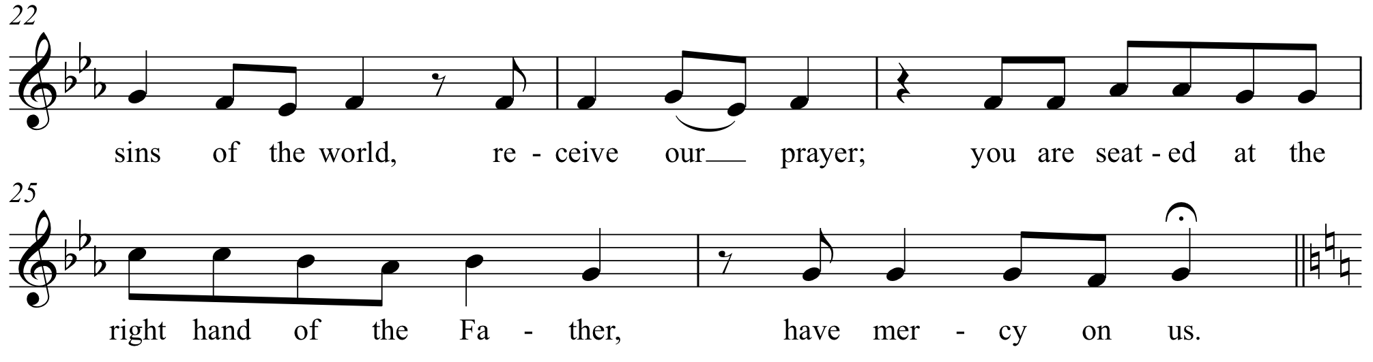

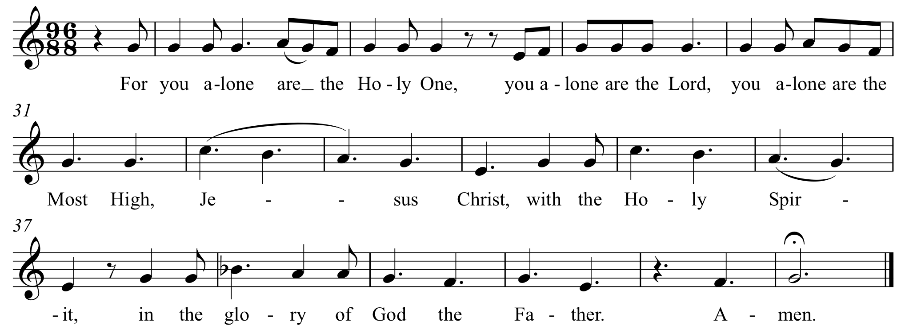

Mews Mass – Gloria

Douglas Mews
Glory to God in the highest,
and on earth peace to people of good will.
We praise you,
we bless you,
we adore you,
we glorify you,
we give you thanks for your great glory,
Lord God, heavenly King
O God, almighty Father.

Lord Jesus Christ, Only Begotten Son,
Lord God, Lamb of God, Son of the Father,
you take away the sins of the world,
have mercy on us;
you take away the sins of the world, receive our prayer;
you are seated at the right hand of the Father,
have mercy on us.
For you alone are the Holy One,
you alone are the Lord,
you alone are the Most High,
Jesus Christ,
with the Holy Spirit,
in the glory of God the Father.
Amen.

Mews Mass – Holy, Holy

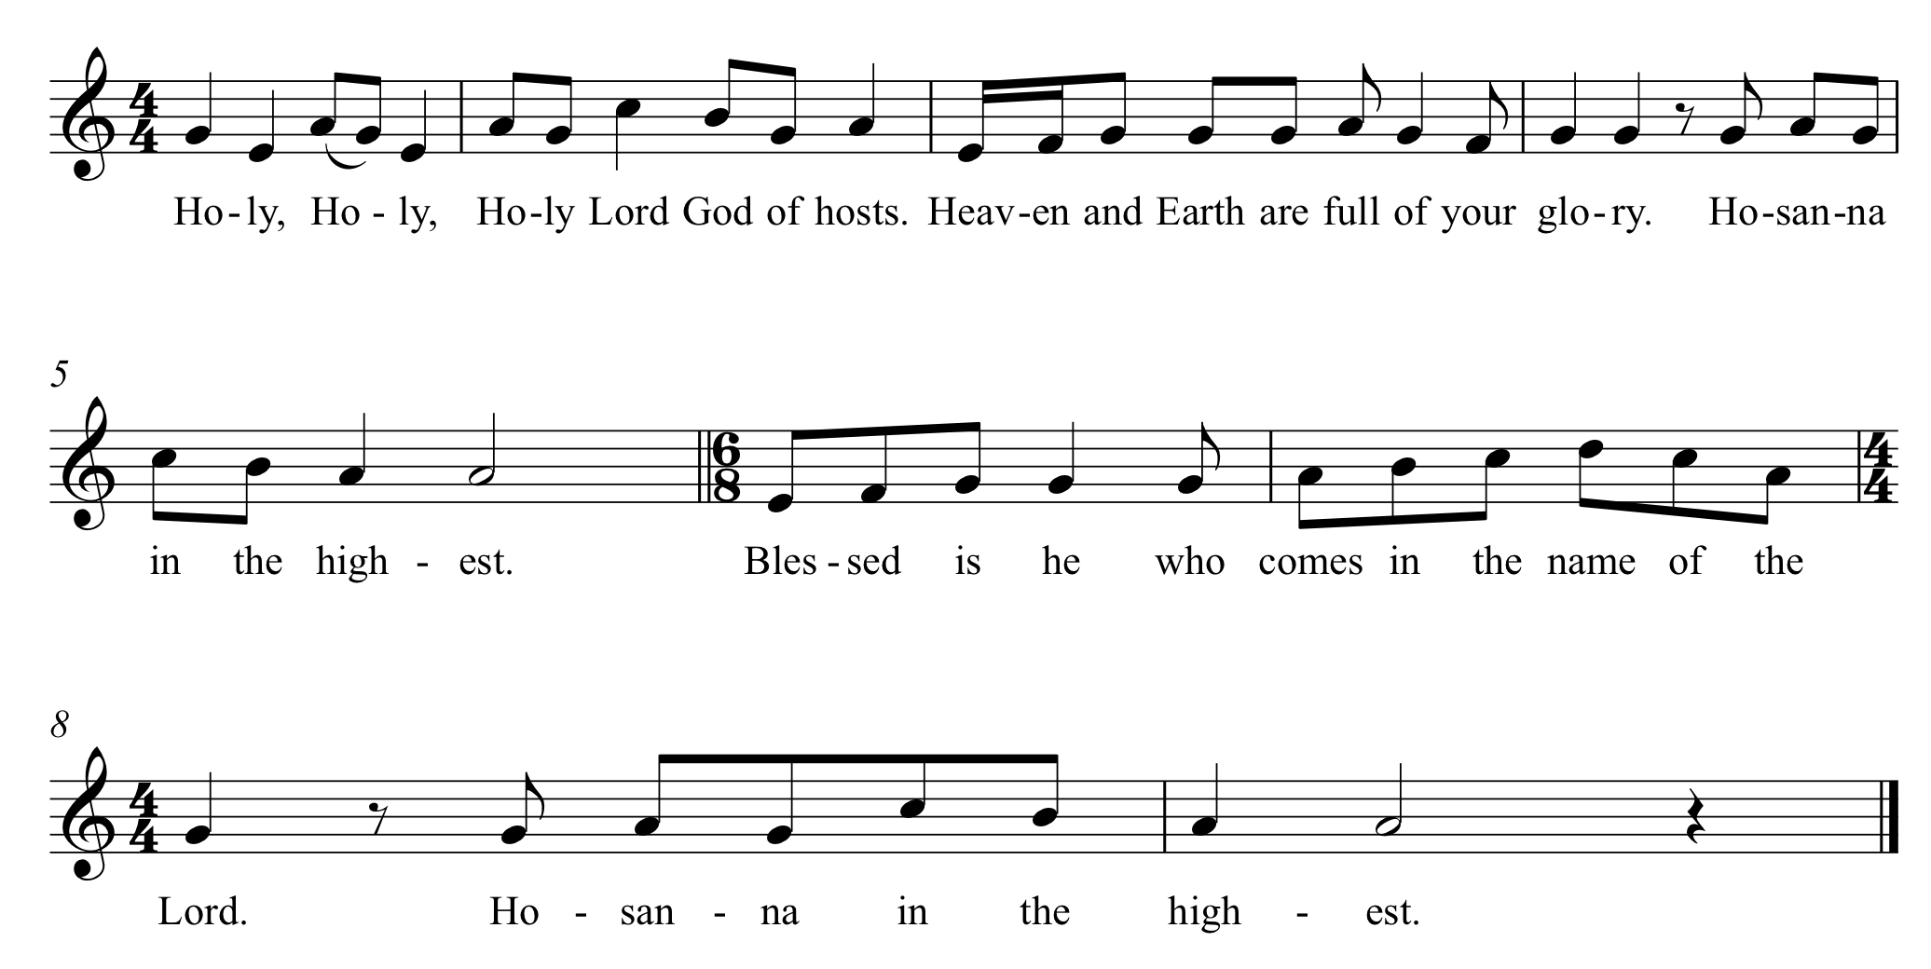
Douglas Mews

Mews Mass – Holy, Holy

Douglas Mews
Holy, Holy, Holy Lord God of hosts.
Heaven and earth are full of your glory.
Hosanna in the highest.
Blessed is he who comes in the name of the Lord.
Hosanna in the highest.

Mews Mass – Acclamation 1

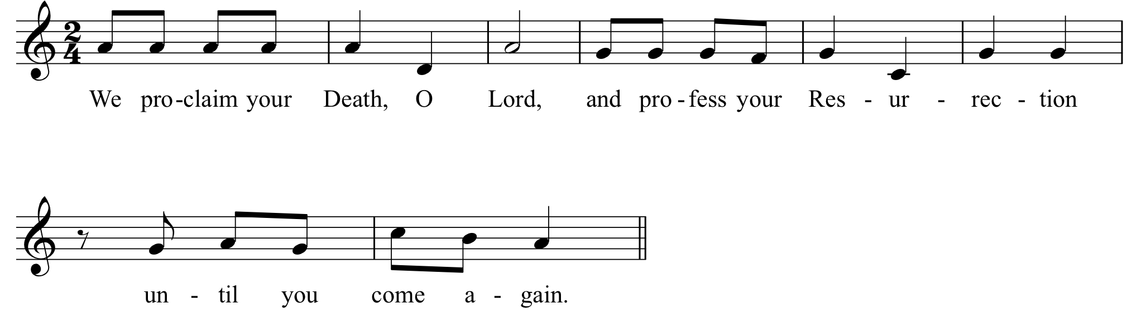
Douglas Mews

Mews Mass – Acclamation 1

Douglas Mews

We proclaim your Death, O Lord,
and profess your Resurrection
until you come again.

Mews Mass – Acclamation 2

Douglas Mews
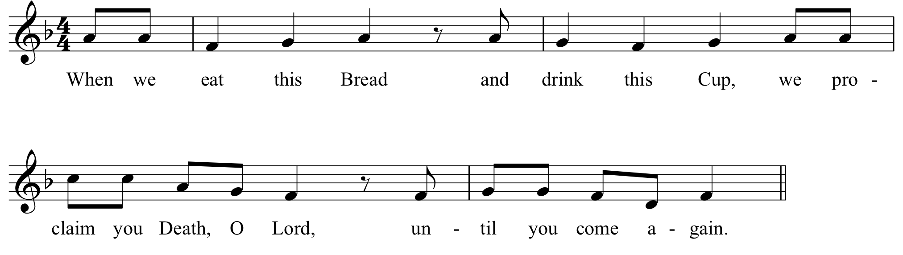

Mews Mass – Acclamation 2

Douglas Mews
When we eat this Bread and drink this Cup,
we proclaim your Death, O Lord,
until you come again.

Mews Mass – Acclamation 3

Douglas Mews
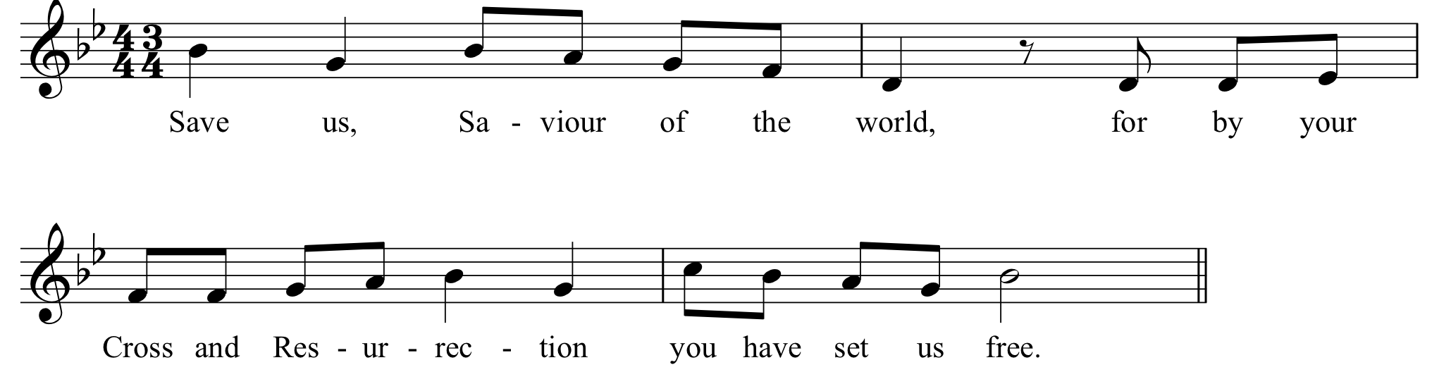

Mews Mass – Acclamation 3

Douglas Mews
Save us, Saviour of the world,
for by your Cross and Resurrection
you have set us free.

Mews Mass – Great Amen

Douglas Mews
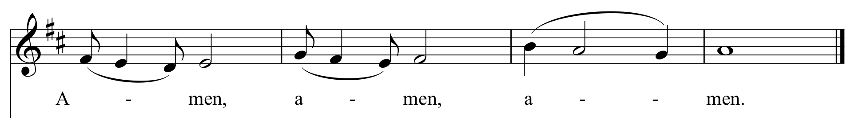

Mews Mass – Great Amen

Douglas Mews
Amen. Amen. Amen.

Mews Mass – Lamb of God

Douglas Mews
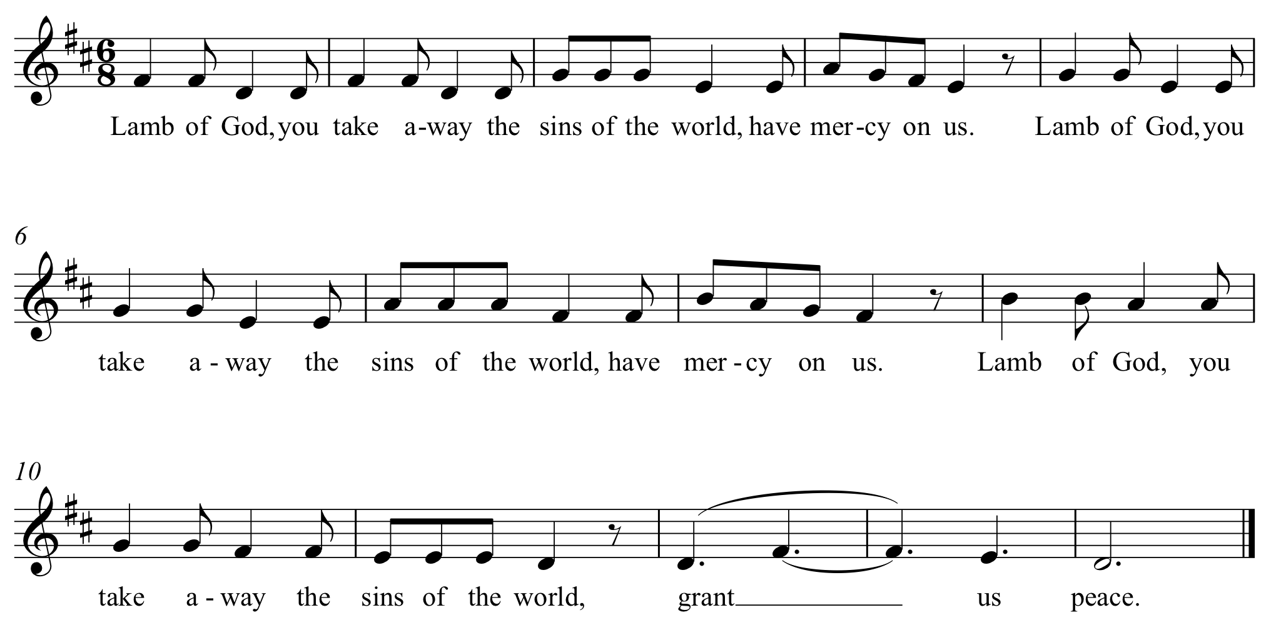

Mews Mass – Lamb of God

Douglas Mews
Lamb of God, you take away the sins of the world, have mercy on us.
Lamb of God, you take away the sins of the world, have mercy on us.
Lamb of God, you take away the sins of the world, grant us peace.

